Department of EEE
Details of Events done during last 6 months

Event-1: Expert lecture on "Real world applications of ML/AI - Exploring careers paths in Data Science”.
A one hour lecture on the topic cited above was conducted on 25.06.2022, for faculty and students of all the departments, in online mode. This lecture was delivered by Mr. Manish kumar who is working as Sr. Associate Director – (Product) with GirnarSoft, Gurugram. He is an alumni of GTBIT and IIM Indore and has 7 years of experience in this field. The lecture was conducted from 12-1pm on Google meet and was successfully attended by 25 participants, however no certificates were issued. This event was organised by Ms. Anita Choudhary of EEE department under expert lecture series.
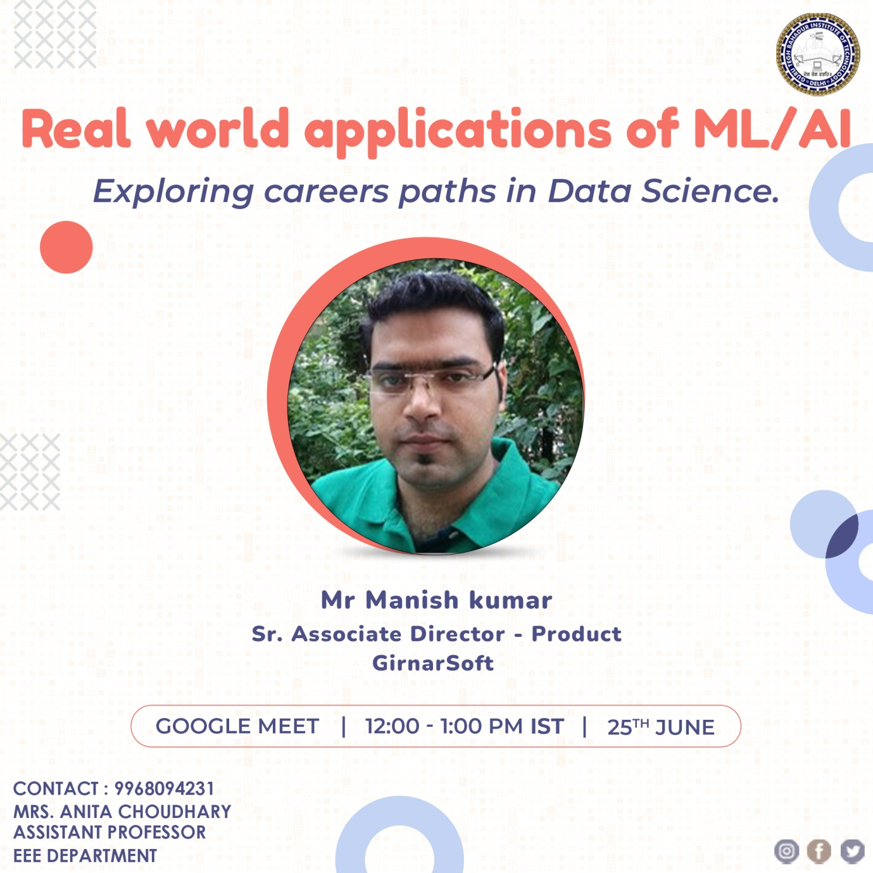

Event-2: Expert lecture on "Recent advances in Smart Grid”
A one hour lecture on the topic cited above was conducted on 02.07.2022, for faculty and students of all the departments, in online mode. This lecture was delivered by Dr. Mahender Singh who is working as Deputy Director, NPTI (Govt. Of India), Faridabad. He is an expert professional in the field with more than 16 years of experience. The lecture was conducted from 12-1pm on Google meet and was successfully attended by 38 participants, however no certificates were issued. This event was organised by Dr. Deepali Sharma of EEE department under expert lecture series.
